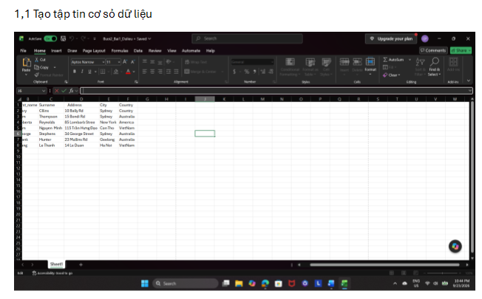1.2 Tạo tập tin chính và Trộn thư
Thực hiện trộn thư:
«Title» «First_name» «Surname»
«Address»
«City»
«Country»
Dear Participant
3/2 Street
CanTho
VietNam
As you may be aware we have been running a variety of courses at the college ranging from 1 week to 12 weeks. We are now happy to inform you that we are introducing a number of 2-day courses, which will be held both at weekends and mid-week to suit the varying needs of potential students.
Please find enclosed an application form and a program schedule. We look forward to your participation.
Yours truly,
Course Director
1.3 Xuất kết quả trộn thư
Mrs Mary Collins 3/2 Street
10 Bally Rd CanTho
Sydney VietNam
Australia

Dear Participant

As you may be aware we have been running a variety of courses at the college
ranging from 1 to 12 weeks. We are now happy to inform you that we are
introducing a number of 2-day courses, which will be held both at weekends and
mid-week to suit the varying needs of potential students.

Please find enclosed an application form and a program schedule. We look forward
to your participation.

Yours truly,

Course Director
Mr Tom Thompson 3/2 Street
15 Bondi Rd CanTho
Sydney VietNam
Australia

Dear Participant

As you may be aware we have been running a variety of courses at the college
ranging from 1 to 12 weeks. We are now happy to inform you that we are
introducing a number of 2-day courses, which will be held both at weekends and
mid-week to suit the varying needs of potential students.

Please find enclosed an application form and a program schedule. We look forward
to your participation.

Yours truly,

Course Director
Ms Roberta Reynolds 3/2 Street
85 Lombard Street CanTho
New York VietNam
America

Dear Participant

As you may be aware we have been running a variety of courses at the college
ranging from 1 to 12 weeks. We are now happy to inform you that we are
introducing a number of 2-day courses, which will be held both at weekends and
mid-week to suit the varying needs of potential students.

Please find enclosed an application form and a program schedule. We look forward
to your participation.

Yours truly,

Course Director
Mr Tâm Nguyen Minh 3/2 Street
115 Trần Hưng Đạo CanTho
CanTho VietNam
VietNam

Dear Participant

As you may be aware we have been running a variety of courses at the college
ranging from 1 to 12 weeks. We are now happy to inform you that we are
introducing a number of 2-day courses, which will be held both at weekends and
mid-week to suit the varying needs of potential students.

Please find enclosed an application form and a program schedule. We look forward
to your participation.

Yours truly,

Course Director
Ms George Stephens 3/2 Street
34 George Street CanTho
Sydney VietNam
Australia

Dear Participant

As you may be aware we have been running a variety of courses at the college
ranging from 1 to 12 weeks. We are now happy to inform you that we are
introducing a number of 2-day courses, which will be held both at weekends and
mid-week to suit the varying needs of potential students.

Please find enclosed an application form and a program schedule. We look forward
to your participation.

Yours truly,

Course Director
Mr Frank Hunter 3/2 Street
23 Mullins Rd CanTho
Geelong VietNam
Australia

Dear Participant

As you may be aware we have been running a variety of courses at the college
ranging from 1 to 12 weeks. We are now happy to inform you that we are
introducing a number of 2-day courses, which will be held both at weekends and
mid-week to suit the varying needs of potential students.

Please find enclosed an application form and a program schedule. We look forward
to your participation.

Yours truly,

Course Director
Ms Hang Le Thanh 3/2 Street
14 Le Duan CanTho
Ha Noi VietNam
VietNam

Dear Participant

As you may be aware we have been running a variety of courses at the college
ranging from 1 to 12 weeks. We are now happy to inform you that we are
introducing a number of 2-day courses, which will be held both at weekends and
mid-week to suit the varying needs of potential students.

Please find enclosed an application form and a program schedule. We look forward
to your participation.

Yours truly,

Course Director

